FixFlow — Requirements Specification
Database course project · Phone & tablet repair shop ticketing system · Oct 11, 2026

Overview
FixFlow is a single-location desktop application for an independent phone & tablet repair shop. One service-desk operator registers customers and devices, opens a repair ticket at intake, records a diagnosis, builds an estimate from catalog services and parts, tracks the repair to completion, takes payment, and — when the same problem recurs — opens a linked warranty-claim ticket against the original repair.
The design holds to 8 tables (6 core entities + 2 junction tables), inside the course's 4–8 entity guideline, while still covering the workflow steps a professor would expect: diagnosis recorded separately from the customer's reported issue, a documented intake condition, and a traceable warranty-claim chain.

Real-world scope
One independent repair shop — not a chain, not a mail-in national repair service, not a manufacturer-authorized service center. One counter PC, used by one service advisor at a time. Technicians perform the repairs but don't log in to the system themselves; the advisor records what they report.
This matches how small repair shops run in practice: records live at the front desk, on one machine, with exactly one person entering transactions at a time — which is why a single-machine desktop app, not a multi-user networked system, is the right fit.

Workflow narrative
A customer arrives with a device. The advisor finds the customer and device by name, phone, or serial/IMEI, or registers both if new. A repair ticket is opened recording the reported issue and the device's intake condition — written down before any work starts, so the shop isn't blamed later for pre-existing damage.
A technician diagnoses the device. The diagnosis is recorded separately from the reported issue, because they often differ — "won't charge" can turn out to be a bad port rather than the battery the customer suspected. From the diagnosis, the advisor builds an estimate: one or more catalog repair types and the parts each needs, each line priced from the current catalog. The customer approves or declines.
On approval, the ticket moves through repair, parts are drawn from stock as lines are added, and the ticket is marked Completed once testing passes. The customer pays at pickup and the ticket closes. If the same problem returns within the warranty window, a new ticket is opened and linked back to the original as a warranty claim, rather than treated as an unrelated repair.

Entities & attributes
Six core entities plus the two junction tables their many-to-many relationships require — eight tables in total.

Customer
The device owner and the person billed.
Field | Type | Notes
customer_id | INT | Primary key
full_name | VARCHAR(100) | Required
phone | VARCHAR(20) | Required, used for lookup at the counter
email | VARCHAR(100) | Optional
address | VARCHAR(150) | Optional

Device
The physical phone or tablet. Repair history and warranty claims attach to the device, not the customer, since one customer may own several devices.
Field | Type | Notes
device_id | INT | Primary key
customer_id | INT | Foreign key → Customer
brand | VARCHAR(50) | e.g. Apple, Samsung
model | VARCHAR(50) | e.g. iPhone 13, Galaxy A54
device_type | VARCHAR(20) | Phone / Tablet
serial_or_imei | VARCHAR(50) | Nullable — some devices arrive dead; unique when present
color | VARCHAR(30) | Optional

Technician
Who actually performs each repair line.
Field | Type | Notes
technician_id | INT | Primary key
full_name | VARCHAR(100) | Required
specialty | VARCHAR(50) | Optional, e.g. "water damage"
is_active | BOOLEAN | Default TRUE; inactive instead of deleted

RepairType
The shop's price list of standard jobs.
Field | Type | Notes
repair_type_id | INT | Primary key
name | VARCHAR(80) | e.g. "Screen Replacement", "Diagnostic Fee"
standard_price | DECIMAL(8,2) | Catalog price
standard_minutes | INT | Typical duration, for scheduling/reporting

Part
Model-specific components and their stock level.
Field | Type | Notes
part_id | INT | Primary key
part_number | VARCHAR(40) | Optional internal/supplier code
name | VARCHAR(80) | e.g. "iPhone 13 Screen"
compatible_model | VARCHAR(50) | Which device model it fits
unit_price | DECIMAL(8,2) | Current catalog price
quantity_on_hand | INT | Current stock; CHECK ≥ 0
reorder_level | INT | Triggers the low-stock report

RepairTicket
One visit/case, from intake to closing — the central transaction.
Field | Type | Notes
ticket_id | INT | Primary key
device_id | INT | Foreign key → Device
reported_issue | VARCHAR(255) | What the customer said
diagnosis_notes | VARCHAR(255) | Nullable until diagnosed; may differ from reported issue
intake_condition | VARCHAR(255) | Required before diagnosis starts
status | VARCHAR(20) | See business rules for the full flow
received_date | DATE | Required
completed_date | DATE | Nullable
closed_date | DATE | Nullable
warranty_days | INT | Default 90
original_ticket_id | INT | Nullable, self-referencing FK → RepairTicket (set only on warranty-claim tickets)
payment_amount | DECIMAL(8,2) | Nullable until paid
payment_method | VARCHAR(20) | Cash / Card / etc.
payment_date | DATE | Nullable

RepairTicketItem — junction
Which catalog repair types were performed on a given ticket, by whom. A visit is rarely one job — screen and battery often happen together — so this is a line-item table, not a single field on the ticket.
Field | Type | Notes
ticket_item_id | INT | Primary key
ticket_id | INT | Foreign key → RepairTicket
repair_type_id | INT | Foreign key → RepairType
technician_id | INT | Foreign key → Technician
quantity | INT | Default 1
price_charged | DECIMAL(8,2) | Snapshot of RepairType.standard_price when the line was added

RepairTicketPart — junction
Which parts were used on a given ticket — same pattern as RepairTicketItem, one level down.
Field | Type | Notes
ticket_part_id | INT | Primary key
ticket_id | INT | Foreign key → RepairTicket
part_id | INT | Foreign key → Part
quantity_used | INT | Default 1; cannot exceed stock at time of entry
unit_price_charged | DECIMAL(8,2) | Snapshot of Part.unit_price when the line was added

Relationships
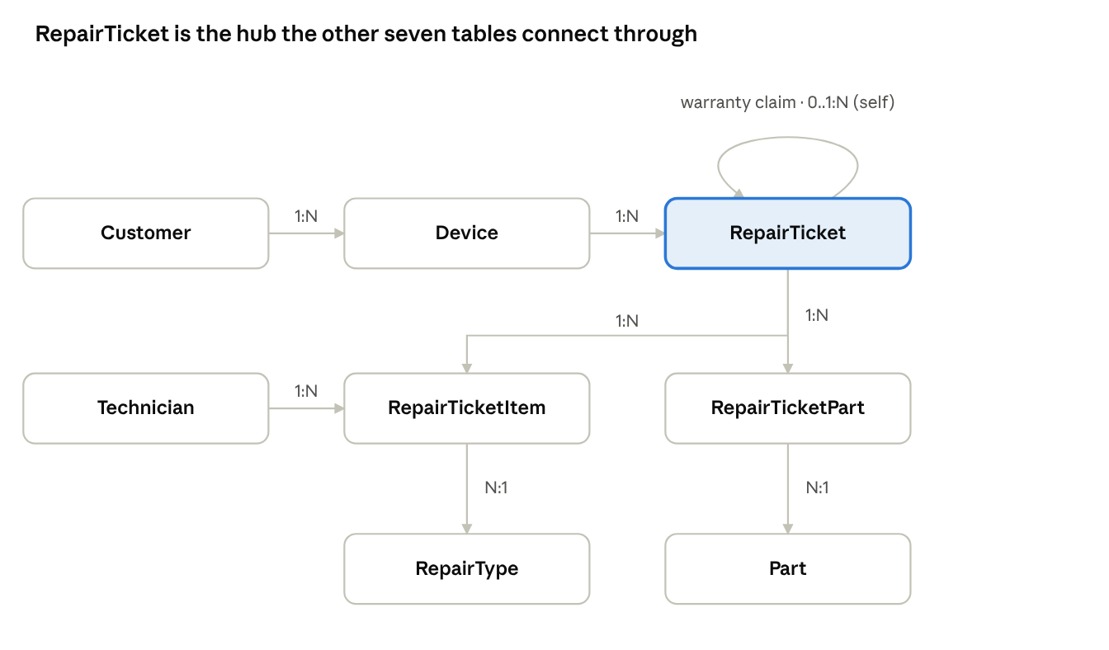
entity relationship map · 8 tables
RepairTicketItem and RepairTicketPart are junction tables: each row pairs one ticket with one catalog row (a service or a part) plus the quantity and price charged. The dashed loop on RepairTicket is the warranty-claim link — a ticket may optionally point back to one earlier ticket for the same device.

Business rules
Numbered so the ERD, SQL constraints, and Java validation can all reference the same rule by ID.
- A customer can own multiple devices; each device belongs to exactly one customer.
- Serial/IMEI is unique when present, but may be null at intake (a dead device can't always be identified yet).
- A device can have many tickets over time, but at most one ticket that isn't in a terminal status (Closed, Declined, Unrepairable) open at once.
- Status flow: Received → Diagnosed → Estimate Given → (Approved | Declined) → In Progress → Completed → Closed. Unrepairable is reachable from Diagnosed. Declined and Unrepairable are terminal.
- Diagnosis notes are required before an estimate can be built, and may differ from the customer's reported issue.
- Intake condition notes are required before diagnosis starts, to protect the shop from disputes over pre-existing cosmetic damage.
- RepairTicketItem / RepairTicketPart lines can be added or changed only while the ticket is between Estimate Given and Completed — not before (nothing to estimate yet) and not after (the record is final).
- Quantity of a part used cannot exceed Part.quantity_on_hand at the moment the line is added; stock decrements immediately when the line is saved.
- Line prices (price_charged, unit_price_charged) are copied from the catalog when the line is created, so a later catalog price change never alters an old ticket's total.
- Ticket total = Σ(RepairTicketItem.quantity × price_charged) + Σ(RepairTicketPart.quantity_used × unit_price_charged).
- original_ticket_id, when set, must reference an earlier ticket for the same device — a claim is always against that device's own history.
- Whether a claim is a valid warranty recurrence (charged $0) or an unrelated new problem (charged normally) is a judgment call the technician records on the claim ticket; it is not inferred automatically.
- A ticket cannot move to Closed without a recorded payment_amount matching its total (or an explicit zero-charge note for a valid warranty claim).
- Inactive technicians cannot be assigned to new RepairTicketItem rows.
- Nothing with history is hard-deleted: tickets, ticket items, and ticket parts are permanent. Customers, devices, technicians, parts, and repair types are deactivated instead of removed.
- Restocking is a manual update to Part.quantity_on_hand by staff — there is no purchase-order workflow in this version.

Functional requirements / operations
- Setup: register customer and device; search by name, phone, or serial/IMEI; manage the RepairType and Part catalogs; add/deactivate technicians.
- Ticket workflow: open a ticket (reported issue + intake condition); record diagnosis; add/remove service and part lines to build an estimate; approve or decline; advance status through repair; complete; record payment and close.
- Warranty: open a claim ticket linked to an eligible prior ticket for the same device; mark a claim valid or not.
- Inventory: view current stock and low-stock parts (quantity_on_hand ≤ reorder_level); manually adjust stock.
- History & reporting: full ticket history for a device, including its warranty-claim chain; revenue by month; most-common repair types; technician workload; warranty-claim rate; average turnaround time (received_date → completed_date); tickets still open past N days.

Assumptions
- One location, one front-desk operator entering data at a time.
- One payment is recorded per ticket, taken at pickup.
- Restocking is a manual quantity update; there is no supplier or purchase-order record in this version.
- A technician's specialty is a free-text label, not an enforced matrix of who may perform which repair type.
- Reported issue and diagnosis are each a single free-text field, not a structured symptom catalog.

Out of scope
Explicitly excluded from this submission, not overlooked:
- Accessory/merchandise retail (cases, screen protectors) — a separate point-of-sale domain.
- Trade-in or buyback of used devices — a different business model (grading, resale pricing).
- Multiple shop locations.
- Mail-in or shipping logistics.
- Manufacturer warranty / insurance-claim reimbursement programs (a separate B2B workflow).
- Appointment scheduling calendar.
- A customer-facing status portal or SMS/email notifications.

